Case 13-US-OH-Adams Cty-Bannerstone-Banded Slate

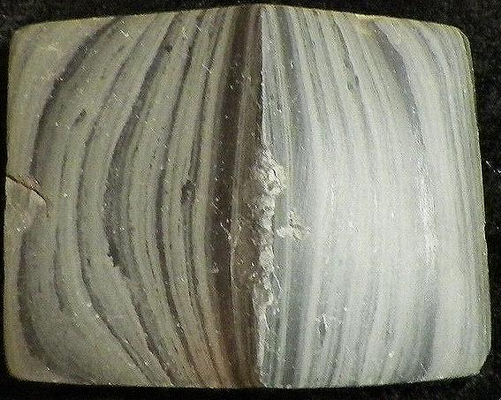

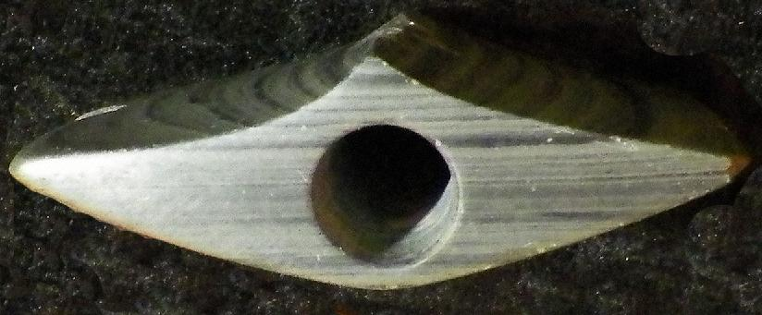

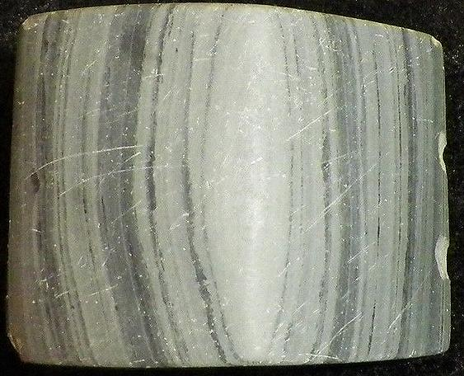
- Case No.: 13
- Accession Number:
- Formal Label:
- Display Description:
- LC Classification:
- Date or Time Horizon: Originates from the "Woodland to Archaic" period
- Geographical Area: Adams County Ohio
- Map:
- GPS Coordinates:
- Cultural Affiliation: Ex Patterson Collection
- Medium: banded slate
- Dimensions: 2-7/8"L by 2-1/8
Weight:
- Provenance:
- Condition:
- Discussion:
- References:

Order details

Sales order
Sold by razorbacknation2... ( 938 )

Delivery package 1 of 1
Estimated delivery Tuesday, Jan 12, 2016
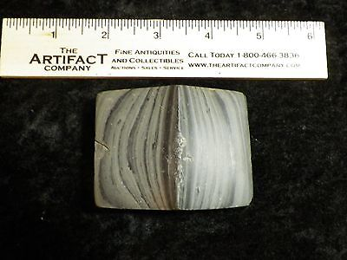

Authentic Ohio Slate Bannerstone Indian Artifact
Item price | $200.00
Quantity | 1
Item number | 191766409979
Shipping service | Economy Shipping

Shipping address
Ralph J Coffman Jr
149 Atlantic Ave
Swampscott MA 01907-2427
United States

Order total
Subtotal | $200.00
Shipping | Free
Total $200.00

